Friends and Family Comments October 2023
RESULTS: 181

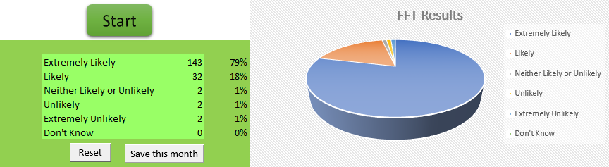

- Receptionist got me an appointment dame morning. Saw doctor and a trainee...both very nice and very thorough. Excellent service
- Went through things with me and if anything I need to know he would answer
- Excellent consultation
- I needed quick medical advice and possibly medication. I got both within a couple of hours of contacting the centre
- Listened
- Nurse professionalism
- The reception are very helpful with a query
- So patient with me
- Although the doctor was in training she was very thorough. I do wish however that we got to choose if we see a doctor in training or experienced. I understand it’s important to train up GPs but sometimes you do need to see someone who is familiar and knows your history
- The doctor listen & did her best treated with respect & the nurse showed me how to use the new device over all 9 out of 10
- The doctor who I saw checked me thoroughly and with a very good attitude. The office staff were very helpful
- You’re all so great you’re tops
- Though I was very anxious and my anxiety was going through the roof doctor n nurse was supportive
- I found the doctor and the nurse that I saw very informative and very understanding a very pleasant experience thank you
- I see Dr Kathuria who's very helpful and friendly Always leave Happy with what she does for me so easy to talk to
- Very kind and not in a hurry
- The member of staff was brilliant
- lovely friendly young lady
- Quick appointment to suit working hours and very helpful Doctor thank you
- Talk me through things, very polite
- Very helpful and understanding. Didn't rush me
- Thorough, invested, on time
- Professional way the consultation was handled
- Maxine on reception goes above and beyond to help, and the doctor and the paramedic were great
- Always helpful
- Polite and friendly service thank you
- Good appointment. GP listened. I didn't feel judged and it felt like a partnership
- Maxine the receptionist goes above and beyond to help, and doctor Jeyam and Stephen are very very helpful
- Booked in an hour before saw the doctor instantly. Staff friendly and positive. Very well run practice
- Very helpful
- No problems very polite quick No long waiting times
- Mollie was very reassuring and friendly. Made me completely at ease ....lovely person
- Very patient junior doctor
- My son as special needs and the staff are always brilliant with him
- Problem wasn't resolved felt like she didn't listen didn't care just fobbed off again
- Dr Kathuria and the staff are very friendly and professional. Well done
- As always a very professional approach to the treatment received
- Seen on time
- All Doctors and staff helpful an kind
- Polite quick and. easy
- Referred me to angina clinic
- Made to feel very relaxed and included in every aspect of consultation.
- First class
- Don't know
- Friendly staff and efficient
- Very nice and polite, went through things with us
- Nice friendly staff
- The surgery is efficient and always prompt
- Friendly helpful staff
- Friendly welcome efficient service and no waiting. Can’t fault my experience
- Friendly staff, always able to get an appointment without having to wait for days, doctors listen to patients which is nice
- I had a flu jab and didn't have to wait long. Also had medical data updated. Very efficiently done
- It is brilliant doctors nurses reception always so friendly and efficient
- Because the staff are very caring and try to fit you in as soon as possible
- Had a problem and was very quick with appointments
- The service was excellent
- Very helpful
- Outstanding service never had any issues what so ever never had any issues with my practice at all
- Pleasant polite staff who dealt with my appointment on time
- Appointment on time, flu jab administered with courtesy
- Excellent professional and thorough in a manner that I felt comfortable and reassured
- Everything went as planned and in a professional manner
- As always a very good professional approach to patients. New practice nurse very good
- Quick, friendly, professional
- The staff on reception are second to none and so helpful and polite
- Excellent professional and thorough in a manner that I felt comfortable and reassured
- Arrived slightly early for our flu jabs but were seen before our allotted time which was brilliant
- Always looking out for patients welfare doctor Shareen was very concerned about my shortness of breathing, prescribed me more of the steroid tablets, also inhaler and a inhaler tube, thanks Doctor Shareen
- Excellent professional and thorough in a manner that I felt comfortable and reassured
- Both receptions very friendly and polite Also both the health Dr very good and professional
- Without exception I was treated professionally and courteously
- I was seen on time
- Janine gave my flu vaccine today and was very pleasant and professional, very satisfied thank you
- It was only an injection so it was in and out but the staff are very good and make you feel at ease
- Got seen 10 mins after my agreed time sent to hospital with a letter
- Reception staff very welcoming & helpful , saw the nurse within 10 mins
- Seen me even though I was there early. Very professional and no pain when she gave me the flu jab
- No fuss straight in appointment on time perfect and as Always friendly helpful staff
- Waited a long time to be seen
- Quick and courteous service throughout thank you
- I saw the nurse and she was great
- Is good
- Efficient and didn't have to wait too long. Good quality of session with nurse
- Dr Kathuria is always so thorough and always listens and tries to help the best way she can
- I thought I was listen to and my concerns where addressed
- Dr Tabassum is a good doctor
- Seen on time. Asked questions to make sure all safe and finished quickly
- Very good experience
- because the nurse made feel relaxed and comfortable
- Went in on time and the nurse was very good
- Appointment on time. The nurse was very efficient and pleasant
- I gave that answer as I went to my doctor's saw a paramedic who didn't sort my tablets out and had to return the next day only to find they still hadn't been sorted
- Didn’t wait to long to get an appointment , and was seen near to the time I was given
- First time I never felt an injection
- Very accommodating & lovely doctors
- Very thorough and helpful made me feel at ease
- Good information and friendly
- Very polite information good happy
- Was see at rite time and was helpful
- Appointments to suit, good communication via app and text. App reminders, friendly, knowledgeable and helpful staff
- On time
- I was very please for service that l received
- On time and helpful
- Very helpful
- Janine was very friendly and professional. She explained everything very clearly. Excellent service

