**Friends and Family Comments September 2024**

**RESULTS**: 228

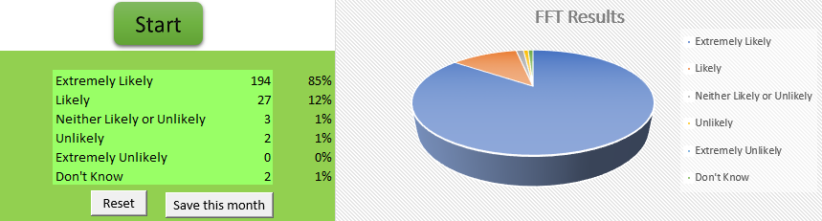

* New young doctor who understood what I was speaking about with time to listen
* Doctors Staff are always good and helpful
* Dr I saw gave me an answer the ha got a colleague in for their advice
* I always receive a very good level of service. I and my family haven't any issues at all
* My blood test appointment was 12.20, I arrived at 12.05 and was back in my vehicle before my 12.20 appointment, I find my surgery very friendly and professional
* On time, very nice
* Very good, He sat and listened to what he was asking me about my cancer even though I was upset
* Dr Sefton is always a great help! Actually listens and get to the root of the problem with no fuss
* Answered all questions and have my tests
* I was treated in a friendly, respectful and professional way at all times. Reception staff were amazing and very helpful. I felt the doctor listened to my concerns and was extremely knowledgeable about my condition. She immediately put me at ease and explained how she could help. She organised follow up appointments and a thorough treatment plan. I came away feeling much happier and with more understanding of my condition. Thank you to all the hardworking staff at the surgery
* I only waited about 5 mins to have bloods taken nurse was very gentle no bruising everything good
* The doctor was very efficient
* I had my bloods taken and everything went as planned and on time
* I was seen on time, treated with courtesy and had my health concerns dealt with consideration and efficiency
* Very helpful thanks for the concern
* Reception staff and nurses absolutely fantastic and the young doctor I saw was very helpful and professional he will go far thank you
* Staff very helpful and polite you can get an appointment and don't have to wait weeks and the doctors and physios I've seen are great very happy
* Reception staff and nurses absolutely fantastic and the young doctor I saw was very helpful and professional he will go far thank you
* I'm struggling in all aspects of my life but the appointment I attended today was up lifting, positive & very supportive
* I always feel heard and confident when I come to the surgery
* An acceptance that a patient can monitor their own BP and weight, and are aware of its importance
* Empathetic nurse. Felt listened to. Fairly painless jab
* Because the nurse I saw today was absolutely brilliant we had a good conversation and a few laps and it was a pleasure to visit you thank you very much
* Always nice & friendly reception staff & helpful Doctors
* Great practice always friendly and helpful
* Easy to book, quick result
* He was very helpful
* Excellent consultation with Dr Rizwaan Lakhi who gave a very thorough review of my condition
* Very helpful and polite
* Easy to get an appointment. Clinics run on time. Appointments were completed promptly
* Nurse very polite, informative and helpful
* Thanks for the concern of the practice & also the chat
* She listened carefully to my problems and got me back for tests even took my bloods without bruising me
* I trust my doctor 100%, I was given medication and follow up advice. I had to visit A&E this morning as I feel so poorly
* I had a pre booked appointment to take bloods. Appointment was on time, lovely nurse took my bloods, it was painless and quick. Thank you
* Very supportive with my mental health issues
* Got an appointment same day brilliant
* I am always pleased with my GP always willing to listen and try to get to the bottom of the problem
* Always listen, friendly explains well very nice caring Doctor
* Admin staff are 5*
* So good to talk to & very helpful
* Very quick, polite and pleasant staff, one slight complaint no been brave badges that I received on my last visit
* Happy polite staff that made the visit easier and quicker than I expected
* Early for my appointment seen to no problem
* The receptionist was very helpful with my enquiry and she sorted out my problem promptly
* Excellent staff as always
* Dr Sefton listened to my problems, showed concern. Very politely confirmed situation. Going to help resolve problems
* Dr El-Lami was very good and has listened to everything I said instead of saying it's my age. He has passed me onto a consultant so hopefully now I have a road forward
* Listen to everything I had to and did a follow up phone call the day after. He had a student in called Elaine and she was very tentative and also listened very happy with the service I had
* A very pleasant doctor took time to examine me and asked the right questions
* Doc very efficient and willing to listen
* The service was excellent, very good
* Seen straight away, polite staff
* The nurse was lovely and friendly and the receptionist was very welcoming and pleasant
* Felt listened to and totally reassured
* Brilliant as always
* The lady was very nice and very friendly
* Professional at all time & felt listen to respected at all time & A&E letter
* Diagnosed and prescribed efficiently
* Went through my options on medication in a way I understood
* The nurse today was excellent, the first time I never felt my injection, brilliant
* Very pleasant, professional, informative lovely lady
* Doctor is very cooperative and receptionist is very friendly
* Yes he was very professional kind caring and he explained things to me
* Over the past 2 days I've been to see a doctor twice regarding health issues + concerns about my surgery & on both visits I have felt 100% reassured by all, including the receptionist/s who are more than willing to help & support you wherever they can
* 100% satisfied with the outcome of my appointment
* Very helpful
* No waiting time went straight in to the nurse
* I got my appointment at short notice and the doctor was very helpful
* Fab service - doctor gave great service. He was really understanding
* I arrived at my GP practice to see Dr Sefton, he gave me time to talk and express my concerns, to which a treatment plan was arranged, clear and concise advice given. 10/10
* Because the doctor I seen has done a good job at finding out what’s wrong with me
* Very friendly reception staff with great knowledge. Appointments are always usually on time. Best Doctors in Bolton. My family are forever grateful to you all
* Quick efficient and lovely paramedic who understood my illness
* My appointment with the doctor was 100% reassuring
* I had two appointments this morning, went straight from one to the other. No waiting at all
* Seeing the health care practitioner today help me to understand a lot more of how to take care of my health she gave me a lot of advice which was very helpful and gave me a greater understanding of how to change my lifestyle
* Received excellent treatment
* I was so pleased with the nurse she was so polite very nice
* On time and good service
* Got an appointment straight away. Reception are professional, never had any issues
* Always helpful, right from reception
* Appointment on time and lovey friendly staff