**Friends and Family Comments November 2024**

**RESULTS**: 143

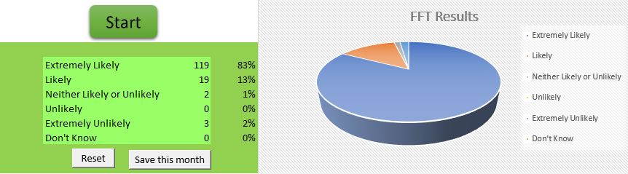

* Got an appointment on the same day Dr was nice and calming with my daughter Offered follow up in home next day with paediatric nurse
* On time
* Very good Dr El-Lami
* Was cancelled due to sickness off staff
* Couldn't fault the surgery in any way best surgery ever been to the lady doctor brilliant she's so kind loving caring does her job
* Couldn't fault the surgery in any way the lady doctor brilliant best doctor I've ever seen
* The GP had a lovely manner and listened
* It was extremely satisfying and informative and I felt very comfortable well done
* Doctor was very easy to talk too he made me feel at ease being has it was only twice l had met him He explained everything to me and quite happy with my treatment
* The doctor was understanding and dealt with my issue promptly and reception staff are friendly and helpful
* They are the best real good all so good
* Very good manners. Explains. Everything. Helpful
* As always everyone more than helpful
* I find the receptionists very polite and helpful. I can always get an appointment and it's a very well organised surgery
* Excellent doctors always has been the doctor I seen was brilliantly
* Excellent
* Brilliant when rung up at 8 am get appointment answered phone straight away give appointment straight away no waiting
* Good service and advice
* Good time and hospitality
* Very good they are all great
* I was waiting for 10 minutes for my appointment
* Polite and friendly
* Welcoming and professional staff. Limited waiting time
* The Dr I saw was amazing and very professional
* Great chat with the doctor who was discussing my recent diagnosis now know there is nothing to worry about
* Went in on time. Was dealt with very well
* Went for bloods and didn't have to wait
* Very nice helpful
* Feel listened to and staff friendly and understanding
* Always helpful and pleasant
* Always listened to
* Dr Charlston was very polite, friendly, and explained things clearly, and gave me the help that I needed. 10 out of 10 Dr Charlston
* Very helpful and friendly
* Appointment was cancelled just 2 hours prior to appointment time. I had already arranged transport
* I was able to be booked an appointment right away. No waiting once at the GP surgery. The reception staff were very kind and the GP Dr Kathuria was thorough. She did not rush to prescribe anything but opted to get to the bottom of the issue and ordered several tests. I am well pleased with my surgery
* Everything went well
* Was seen to before appointment time. Really pleasant experience
* Because I felt at ease with the nurse who was friendly and very polite
* A very positive experience with both Drs
* Amazing doctor, how lovely and very thorough so my experience was an excellent one
* I’m happy
* Whenever I have appointment I'm treated very well
* Helpful receptionist, speedy phlebotomist
* GP listened, involved me in the decision making process and wasn’t pressurised by time
* Great service
* Very professional only for a blood test but very nice
* Good appointment
* I always receive a good service at this Health Centre
* Helpful
* Got seen on the same day which is what you want
* The nurse is lovely very friendly and welcoming
* Easily made appointment & seen on time
* The service was very good
* In & out
* Always very helpful and kind nice to be so pleasant
* Always helpful and kind so pleasant
* Prompt appointment
* Staff were friendly and helpful and offered a smile first thing in the morning, it’s much appreciated and helps as you never know what a person is going through. Well done
* Excellent way I was dealt with
* They are very professional and nothing is a problem
* Very nice
* My mum had an appointment to have a blood test at 11.50, we arrived 15 mins early. Mum had blood test and we walked back through our front door at 11.53. Amazing practice with amazing staff. Thank you
* Very nice my surgery
* Fab service and doctor was attentive and listened to me
* It was a last minute appointment and when I arrived I was first seen by a 4th year trainee and then the doctor it was a very satisfying experience made to feel very welcome
* Very professional staff
* Very kind helpful polite
* At the arranged time and a very pleasant review
* Doctor only offered for me to buy medication from chemist waste of time making appointment while being ill had to go to surgery pathetic
* Very thorough
* Friendly and helpful
* Seen on time given the correct medication
* Extremely happy
* The appointments was on time, GP took her time to listen to my issues, she displayed excellent listening skills and probing questions to obtain more detail. GP explained issues and enabled me to be fully informed about the options available and allowed me to make a decision rather than enforcing a decision on me
* Dr El-Lami was outstanding, it was the most thorough and professional GP consultation I've ever had, the surgery is lucky to have him
* Friendly receptionists and doctor and the quick appointment time
* Felt at easy and everything explained to me professionally and got some very useful extra advice
* Very efficient
* I was very happy to get the appointment and when I came I didn’t have to wait long before I was seen to. I was very pleased with the outcome. I just have to use the item that prescribe for me to see if it work then I will be happy again. Thank you all very much
* Very helpful
* Very efficient
* Very efficient and relaxed
* She was very understandable and friendly
* Appointment on time. Friendly and efficient service
* Nothing special just run of the mill appointment